Simon Technology Services
Technology Handbook

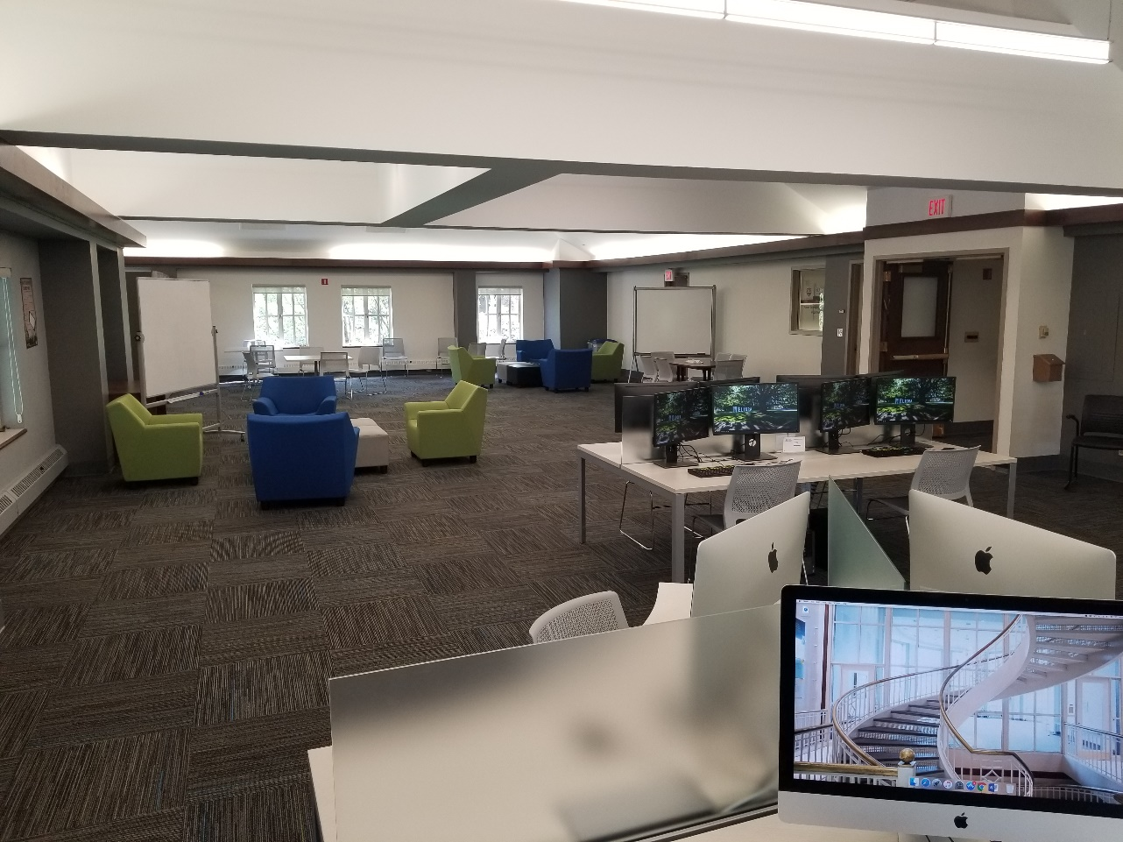

Simon Technology Services
Help Desk – Gleason 335
(585) 275 – 4407
support@simon.rochester.edu
Table of Contents

Simon Credentials 3
Services Overview 4
STS Help Desk Hours – Gleason 335 4
Admitted Student Portals 4
Wireless Access 5
Student Printing 6
Printer Install 6
Printing Rates 6
Printer Locations 6
Simon Email 7
Outlook Configuration 8
iPhone Configuration 12
Android Configuration 15
Blackboard 18
MySimon 19
Library Resources 20
University VPN 21
Best Practices 22
Frequently Asked Questions 23

Simon Credentials

While at Simon, you will have two separate credentials to access University resources:

Your NetID is your account for accessing a variety of online services, such as the Blackboard, Library Resources, MyIdentity Self Service, and the University VPN.

Your Active Directory (AD) is your domain account at the University, used to log in to Simon email, Windows workstations, the UR_Connected wireless network, and other applications.

NetID vs. Active Directory

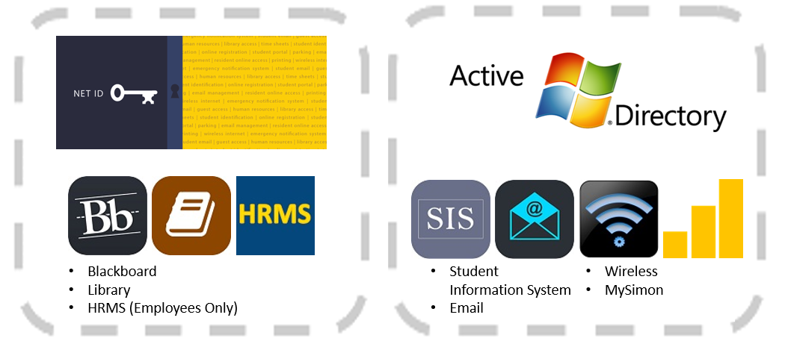

Services Overview

STS can provide a number of services and software packages for you.

  - Microsoft Office 365 ProPlus
  - Antivirus assistance
  - Class required software
  - Mac Users: Please note that we require the use of Parallels (requires a purchase)
    - Once you have purchased Parallels desktop, STS can provide the required Microsoft Windows and Office installation required.
  - Software installs, configurations, & best effort troubleshooting

STS Help Desk Hours – Gleason 335

Monday - Friday: 7:30 am – 9:30 pm
Saturday & Sunday: 7:30 am – 5:00 pm
(Breaks & Summer may differ)

Admitted Student Portals

Self-serve options for software downloads are available online on your admitted student portal:

Full-time MBA portal: bit.ly/mbatech
Full-time MS portal: bit.ly/ms-tech
Executive MBA portal: bit.ly/embatech
Executive MBA in Bern, Switzerland portal: bit.ly/brntech
Professional (Part-time) MBA portal: bit.ly/pmbatech
Medical Management portal: bit.ly/mmptech

Wireless Access

During your time at Simon, we recommend that you use the UR_Connected or UR_Connected5 wireless network. This is the fastest and most secure network and requires only a single login with your Active Directory credentials.

Connect to the UR_Connected or UR_Connected5 network using your UR Active Directory (AD) credentials. Example: ur\username
Please note:
UR_RC_Guest is an open wireless network with no login required. This network is unsecure and should only be used by visitors or individuals not affiliated with the University. This network will not provide you with connectivity to University resources (printers, etc.).

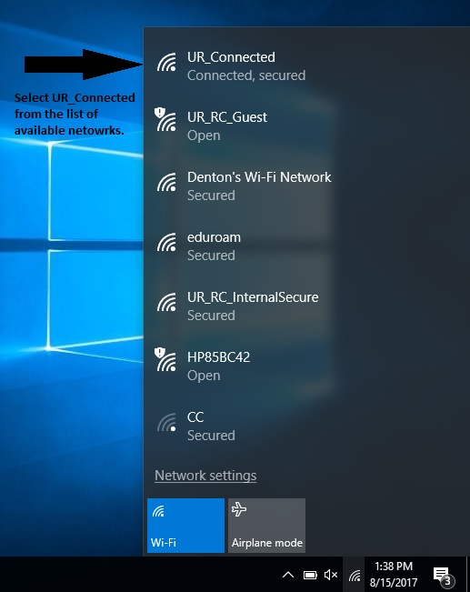

For more information, please visit http://tech.rochester.edu/services/wireless/

Student Printing

Xerox Color printing, mobile printing, scan-to-email, and copying right at the multi-function printers:

Printer Install

- Install the new printers using the links on Simon’s website or stop by the Help Desk in the Collaboration Lab and ask a Consultant for assistance.
- When you want to retrieve your printout; grab your student ID card and head to ANY of the printers
- Swipe your ID card and choose Print Release
- Select your document and Print

Printing Rates  Black and White Printing:  - 1-sided prints will cost $.10 each  - 2-sided prints will cost $.18 each  Color Printing:  - 1-sided prints will cost $.25 each  - 2-sided prints will cost $.48 each  *Note:  There is an option to add more funds to your ID card. (See instructions posted near printers.) | Printer Locations  Black and White Printing:  - Schlegal 4th floor – in between 409 and 410  - Schlegel 3rd floor – Next to 312  - Gleason 3rd Floor – Across from 321  - Schlegel 1st Floor – In between 111 and 112  Color Printing:  - Schlegel 4th Floor – in Collab Lab (Schlegel 404)  - Gleason 1st Floor – Across from 121
Print driver downloads are available for self-service on your admitted student portal. You may also stop to the Help Desk in Gleason 335 for assistance downloading and installing these drivers.

Simon Email

Simon Email requires your UR Active Directory (AD) credentials.

You can access your Simon email on the web by visiting: https://outlook.com/owa/ur.rochester.edu

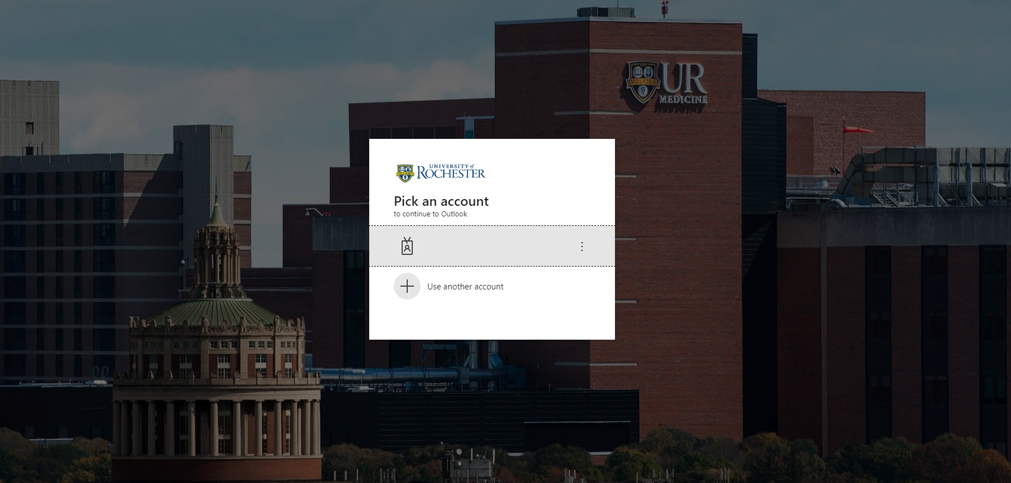

Outlook Configuration

To configure your Simon email into Outlook, please follow the steps below (If configuring Outlook for the first time, please skip steps 1 – 5):

Step 1
Click on Start > Control Panel. At the top right of the window, change the “View By” dropdown to Large (or Small) icons.
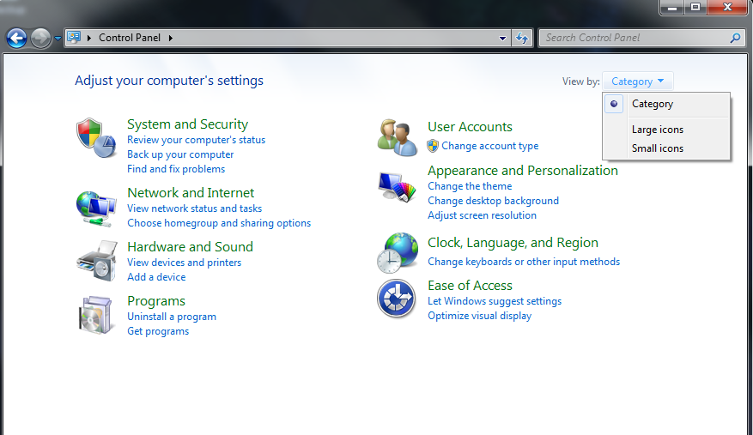

Step 2
Click on the Mail (32-bit) option.

Step 3
A new window will open. Click on Show Profiles.
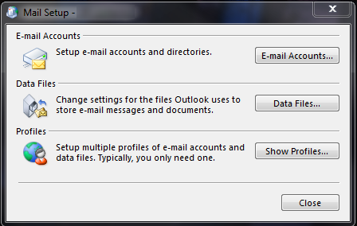
Step 4
Click Add.
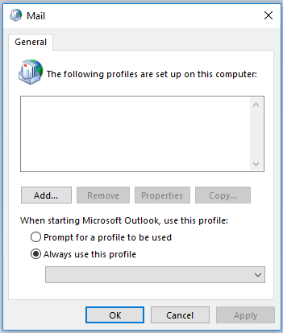

Step 5
Type any name (e.g. Simon, Ur, etc.) into the Profile Name field, then click OK.
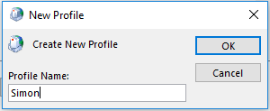
Step 6
Enter your email credentials:
- Enter your name
- Enter your primary email address with the @ur.rochester.edu extension
(e.g., jane.doe@UR.rochester.edu or jdoe@UR.rochester.edu)
  - Please note: During this step you must use ‘@ur.rochester.edu’ rather than ‘@simon.rochester.edu’.
- Enter your password associated with your username in the Password and Retype Password fields.

Then click Next.

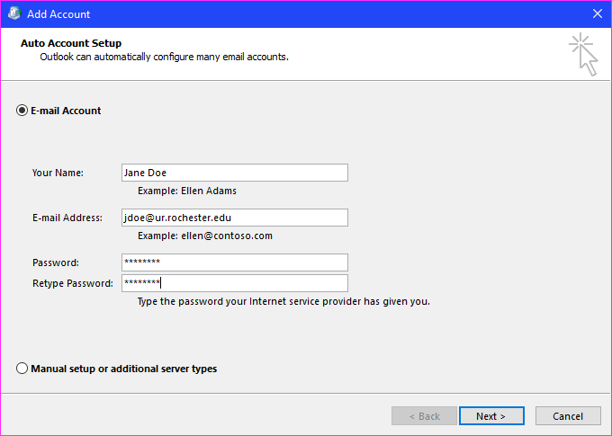

Step 7
It will now begin to search for your email account. Please note: This process may take several minutes (possibly, onward of ten minutes).

Step 8
You may see an Auto discover window. If you do, check the box next to Don’t ask me about this website again, then click Allow.

Step 9
Outlook will continue searching for your email account. This may take several minutes to complete. Once it is finished, you will see a Congratulations window, stating, “Your email account is successfully configured.” Click Finish.

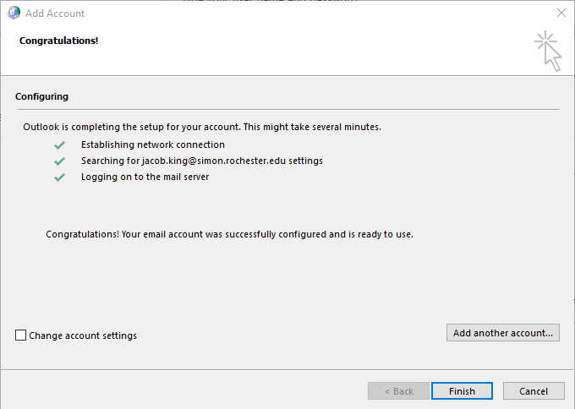

For more information, please visit https://tech.rochester.edu/microsoft-365-tutorials/

iPhone Configuration

Step 1
On the home screen, tap the Settings icon.
Step 2
Select Accounts & Passwords.
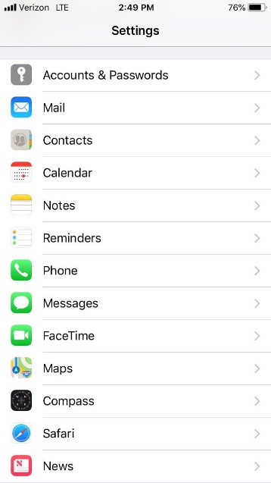
Step 3
Select Add Account.
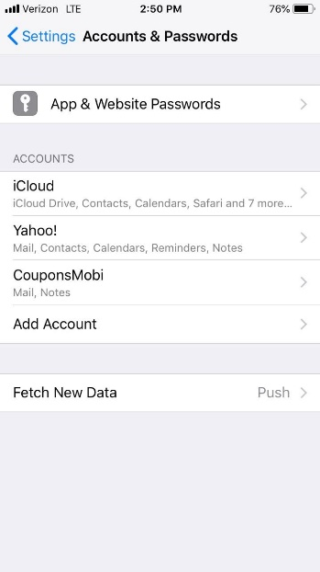

Step 4
Select the Microsoft Exchange option.
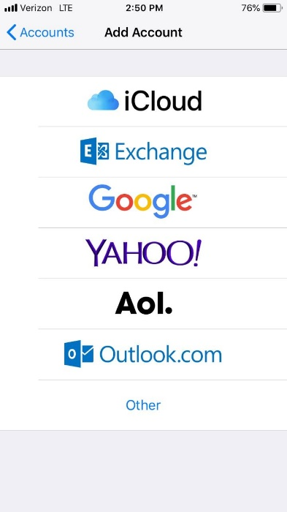
Step 5
- Enter your primary email address
- Enter your password associated with your username
- Enter Simon in the description field
- Tap Next
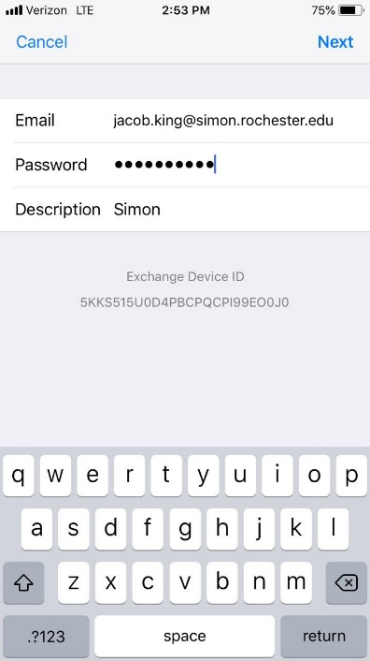
Step 6
Please enter the following:
- Server: outlook.office365.com
- Domain: (leave blank)
- Username: username@ur.rochester.edu
*Please note: During this step, Simon users must use the “@UR.rochester.edu” extension rather than ‘@simon.rochester.edu’.
Tap Done.
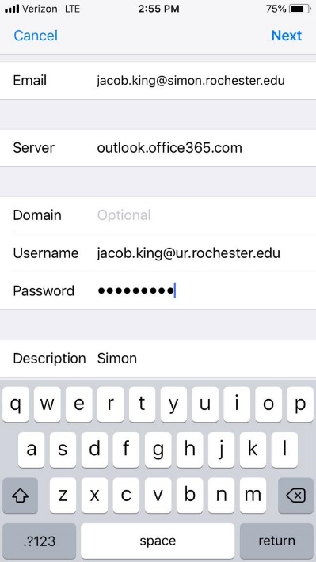
Step 7
Set which features (Mail, Contacts, Calendars, Reminders) you want to sync on your device. Then tap Save.
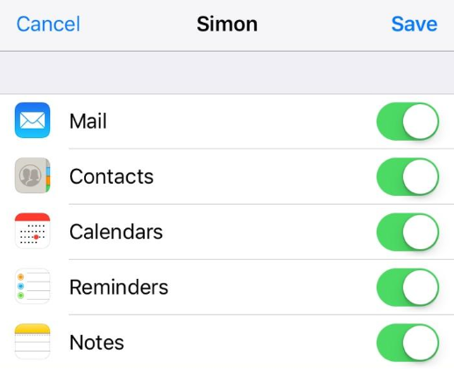
For more information, please visit https://tech.rochester.edu/microsoft-365-tutorials/

Android Configuration

Step 1
On your home screen or app drawer go to Settings.

Step 2
Click on Accounts and backup.

Step 3
Click Accounts.
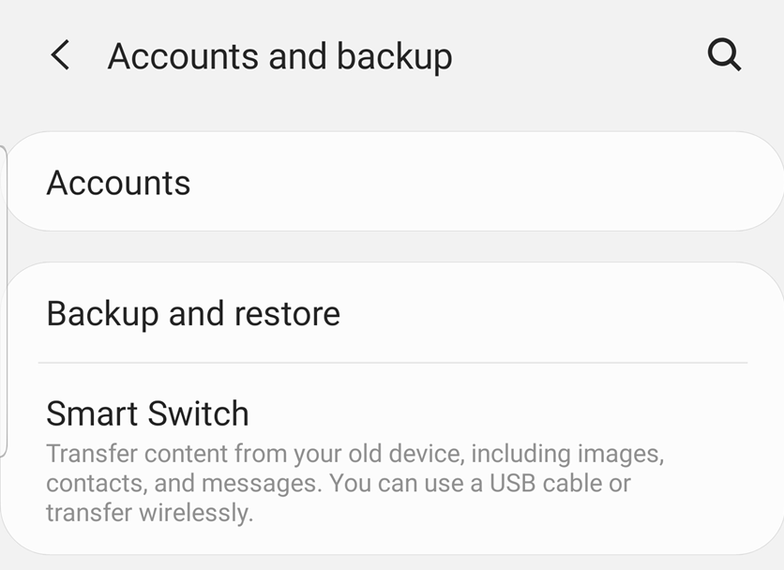

Step 4
Click Add account
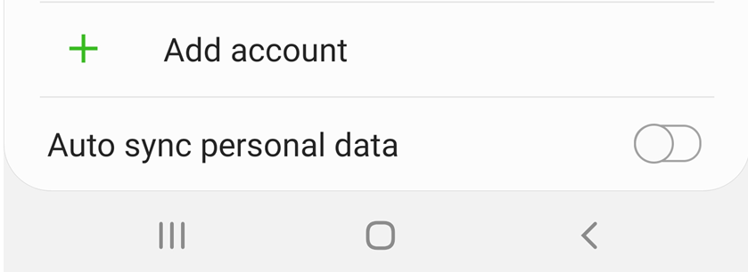

Step 5
Select Exchange

Step 6
Add your email address and then click Manual Setup.

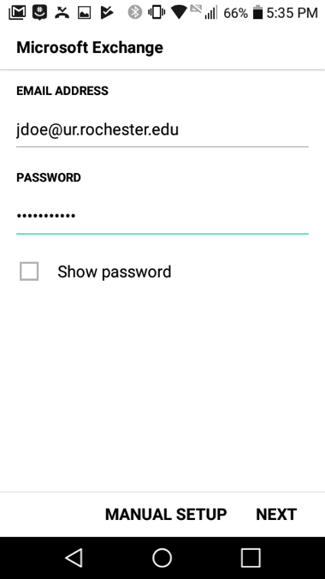

Step 7
Enter your password and select Next.
Then, Enter the following information:
Domain / UR Active Directory Username | jane.doe@ur.rochester.edu or jdoe@ur.rochester.edu (*Please note: During this step, Simon users must use the “@UR.rochester.edu” extension rather than ‘@simon.rochester.edu’.)
Password | Your Active Directory password
Server | outlook.office365.com
Verify Use secure connection (SSL) is checked, then tap Next.
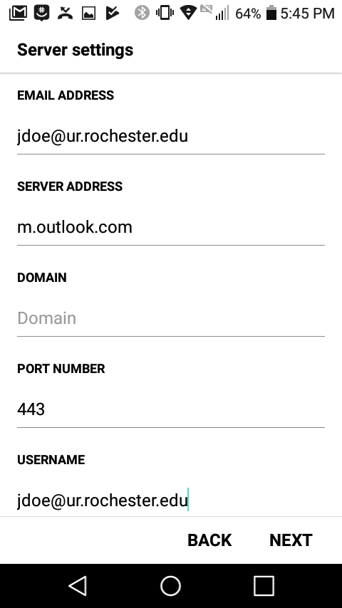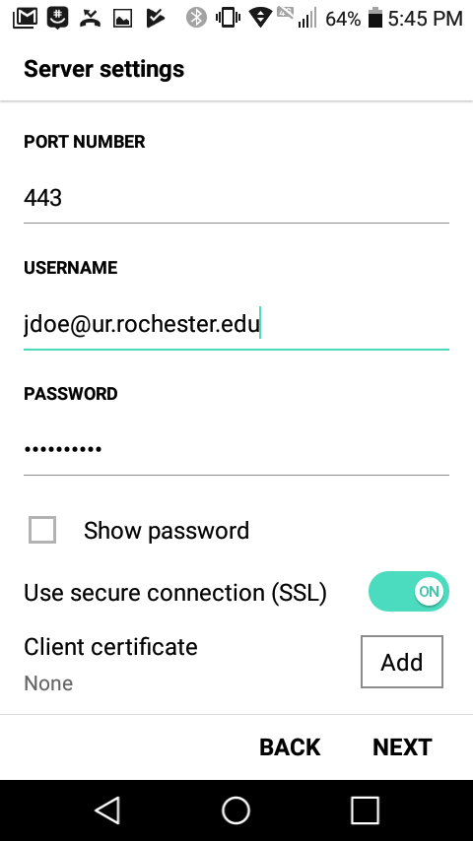
Step 9
You will be prompted to allow remote security administration. Tap OK to complete setup.
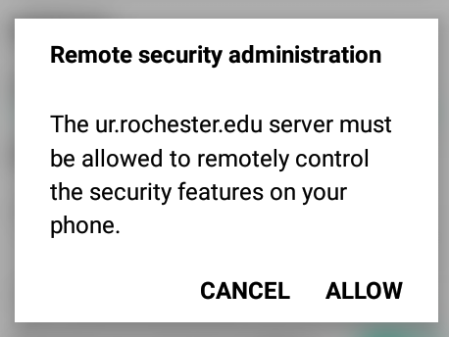

For more information, please visit https://tech.rochester.edu/microsoft-365-tutorials/

Blackboard

http://learn.rochester.edu

Blackboard is a virtual hub for student services that provides access to online course materials, grades, organizations, accounts, and many other academic and campus services.
You can log in to Blackboard using your NetID and password.
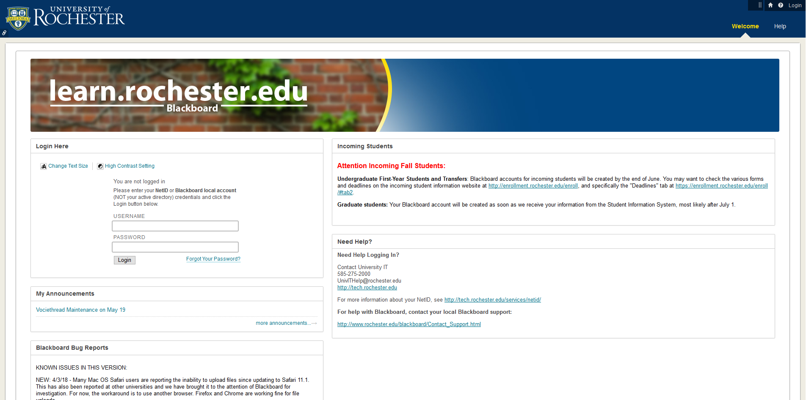
The home page will provide access to your individual course pages and organizations. Navigate to other pages using the tabs at the top of the page.
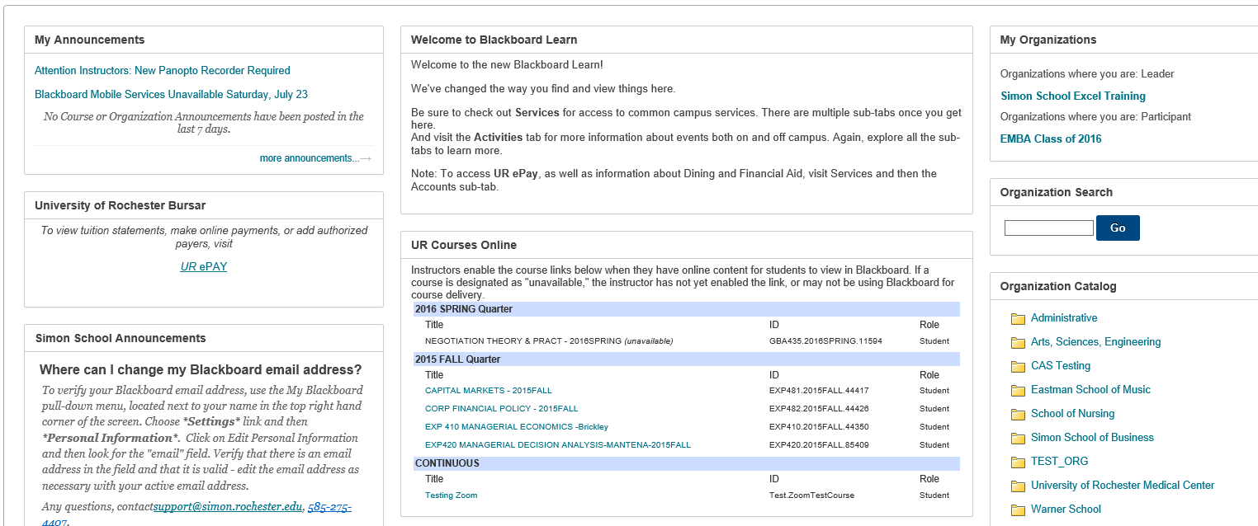

MySimon

http://mysimon.rochester.edu

MySimon is one of the Simon School’s student portals; a way to find all of the information needed to navigate through student programs, Simon Business School, and the University of Rochester.

Some of the information that can be found on My Simon:
- Course information
- Career management
- Clubs and student organizations
- River Campus information
- Simon’s Google Calendar
- Services around UofR
- Integrated social media buttons for Facebook, Twitter, Linkedin, and Instagram
- Up-to-date announcements for university news, events, academic deadlines, trips, job postings, and much more.
- Student Dashboard – visit https://mysimon.rochester.edu/dashboard/

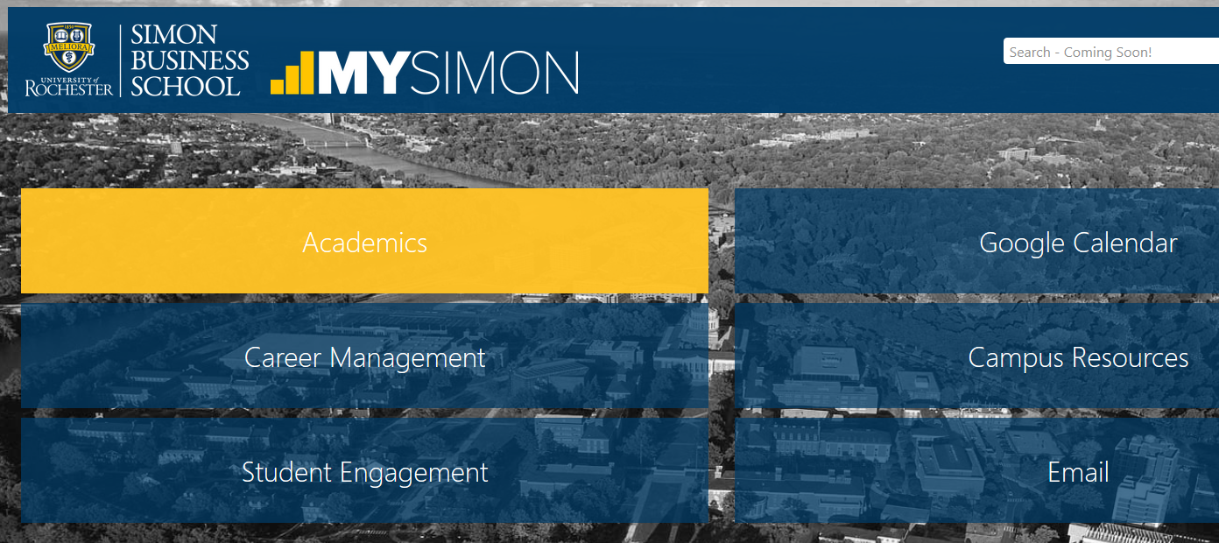

Library Resources

The library has a multitude of online resources, accessible through http://library.rochester.edu and on Blackboard on the “Library Resources” in the left toolbar on each course page.

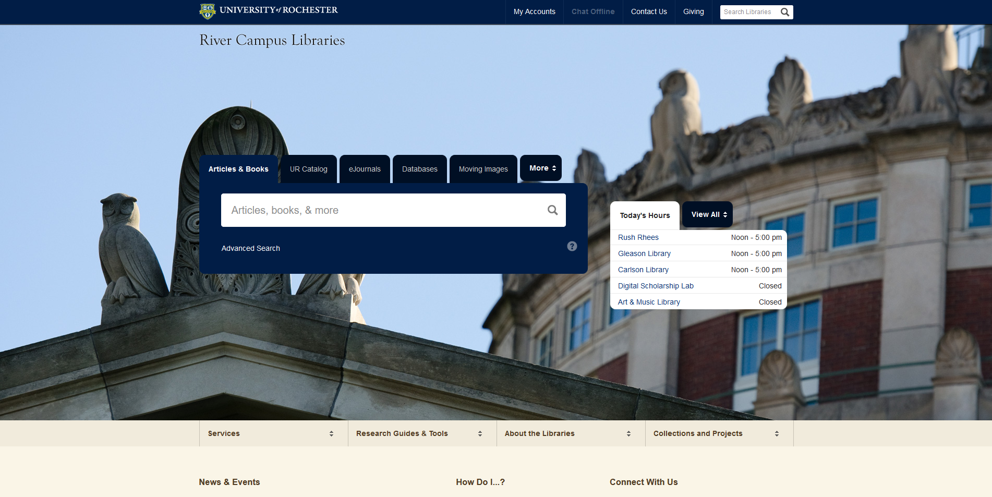

Please note: If searching for resources from off campus – you will be required to log in with your NetID credentials.

University VPN

A Virtual Private Network (VPN) is used to access restricted University resources from off campus through a secured Internet connection. Faculty, staff, and students with a current, active relationship with the University can use VPN. University resources that do not require VPN to access remotely include email, and most library resources.

To install and configure the University VPN:

- Go to http://www.rochester.edu/it/vpn/
- Click ‘Install on (Appropriate OS)’
- Enroll in Duo two-factor authentication
  - Please Note: Unless enrolling in Duo during the account initialization process, you will need to be on campus to do so.
- Go to step 2 – https://vpn.rochester.edu
- Input your NETID Credentials
- Click “Download client’, Click ‘Run’, and then click ‘Allow’ if asked to
- In the Start menu, click All Programs > Cisco > Cisco AnyConnect Secure Mobility Client
- Type in vpn.rochester.edu then click Connect

For additional information please visit http://tech.rochester.edu/services/remote-access-vpn/

Best Practices

- Keep all of your files in one directory (e.g., My Documents, your cloud storage folder)
- Backup often to an external location (preferably the cloud)
- Use Box, GDrive, Dropbox, OneDrive, etc., for Team file sharing
- Keep up with updates: Antivirus, Anti-Spyware, and Operating System updates
- Covet your configuration (Be very picky!)

Frequently Asked Questions

Where do I get a version of Parallels so that I can run Windows on my Mac? Parallels can be purchased from the UR Tech Store in Rush Rhees Library. We can assist with the installation at the Simon Help Desk in Gleason 335.

What software is available on the Collaboration Lab computers? The public computers in the Collaboration Lab contain Bloomberg, Capital IQ, Frontline Risk Solver, R, Adobe Creative Cloud, etc.

Does the STS Help Desk lend out laptops? STS does not lend out laptops. There are Lab Computers located in the Collaboration Lab for student use and can be used while your laptop is being repaired.

Can STS retrieve my data for me? The Computing Lab does not retrieve data from a student’s laptop. The Simon School Information Technology Department highly encourages students to back-up their data every day/use cloud storage. We cannot stress this enough and please make sure to back-up to an EXTERNAL media source.

Contact us:
Visit Gleason 335
Email: Support@simon.rochester.edu
Call: 275-4407

